|  |  |
| --- | --- |
|  | Features: |
|  | Interactive frontend |
|  | - Increases functionality by providing another way of interaction with the program |
|  | - Tested by doctests |
|  | Supports piping and scripting |
|  | - Increases flexibility by allowing images to be drawn through automatic scripts |
|  | - Clever by using regex and aliases to allow for flexible syntax |
|  | - Tested by doctests |
|  | Parsed from configurable lookup tables |
|  | - Increases flexibility by allowing for commands to be added easily and dynamically |
|  | - Clever by using regex for aliases for more flexibility |
|  | - Tested by unit tests and doctests |
|  | Uses regular expressions in parser |
|  | - Increases flexibility by allowing for aliases to be used in scripts |
|  | - Tested by unit tests and doctests |
|  | Uses generic parsing engine |
|  | - Increases functionality by providing an interface that can be used by any drawer |
|  | - Tested by unit tests and doctests |
|  | Outputs with turtle.py |
|  | - Increases functionality by using an alternative form of drawing to the screen |
|  | - Tested by unit tests and doctests |
|  | Provide doctests |
|  | - Improves robustness by testing features and functions for if they are valid and working |
|  | Provide unit tests |
|  | - Improves robustness by testing features and functions for if they are valid and working |
|  | - Clever by dynamically loading tests from a Test Case class in to a test suite |
|  | Breadth of test coverage |
|  | - Improves robustness by ensuring every feature works as expected |
|  | - Every function has been covered |
|  | - Tests done through both unit tests and doctests |
|  | Amount of error trapping & handling |
|  | - Improves robustness by keeping the program running even when errors are found |
|  | - Most functions have error handling to alert the user of issues with input |
|  | - Also used for ensuring data gets handled correctly |

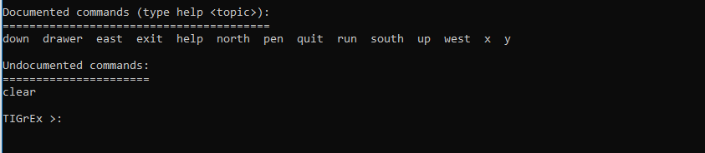

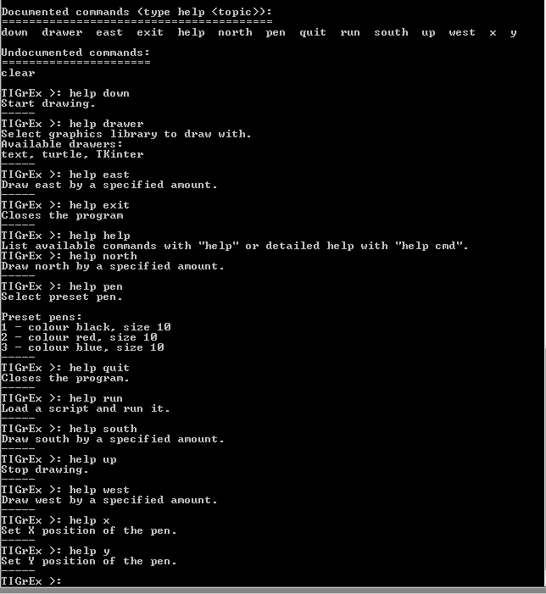

NOTE: NO TKinter in the program